|  |  |  |
| --- | --- | --- |
| VILNIAUS KOLEGIJA  UNIVERSITY OF APPLIED SCIENCES  FACULTY OF ELECTRONICS AND INFORMATICS  BURUNDUKAI | | |
| https://screenshotscdn.firefoxusercontent.com/images/eaf3f7f3-2952-4801-af5c-4f20e8ae8b88.png | | |
| **THE NEEDS OF USERS OF THE DESIGNED SYSTEM** | | |
| GROUP WORK  6531BX028 PI18E | | |
| STUDENTS | (SIGNATURE) | EDITA KOMAROVA  SAULĖ STANKEVIČIŪTĖ    MANTAS PODOLSKIS    DŽIUGAS PEČIULEVIČIUS |
| 2019-03 |
| (SIGNATURE) |
| 2019-03 |
| (SIGNATURE) |
| 2019-03 |
| (SIGNATURE) |
| LECTURER | 2019-03 | SVETLANA KUBILINSKIENE | |
|  | (SIGNATURE) |  |
|  | 2019-03 |  |
| 2019 | | |

**Table of Contents**

Anotation 4

INTRODUCTION 5

1. CATEGORIES OF INTERESTED USERS FOR FUTURE SYSTEM 6

1.1. Primary user groups 6

1.2. Secondary user groups 6

1.3. Tertiary users group 6

1.4. Acquirers 6

2. user groups 7

2.1. A set of functionalities for user groups 7

2.2. First user group (unregistered users) 7

2.2.1 Project objectives 7

2.2.2 User characteristics 7

2.2.3 User types 7

2.2.4 Computerized tasks 7

2.2.5 Problems and unexploited opportunities 8

2.2.6 Vision of improved interaction design 8

2.2.7 Usability goals for the essential computerized tasks 8

2.3. Second user group (registered users) 8

2.3.1 Project objectives 8

2.3.2 User characteristics 8

2.3.3 User types 9

2.3.4Computerized tasks 9

2.3.5 Problems and unexploited opportunities 9

2.3.6 Vision of improved interaction design 9

2.3.7 Usability goals for the essential computerized tasks 10

2.4. Third user group (Company representatives) 10

2.4.1 Project objectives 10

2.4.2 User characteristics 10

2.4.3 User types 10

2.4.4 Computerized tasks 11

2.4.5 Problems and unexploited opportunities 11

2.4.6 Vision of improved interaction design 11

2.4.7 Usability goals for the essential computerized tasks 11

2.5. Fourth user group (Administrators) 11

2.5.1 Project objectives 11

2.5.2 User characteristics 12

2.5.3 User types 12

2.5.4 Computerized tasks 12

2.5.5 Problems and unexploited opportunities 12

2.5.6 Vision of improved interaction design 12

2.5.7 Usability goals for the essential computerized tasks 12

3. INSPIRING INTERACTION IDEAS 13

3.1. Website: “Digital video game store” 13

3.2. Website to purchase games 13

3.3. Website to purchase indie developer games 14

3.4. Website for great game deals 16

3.5. DRM-free (Digital Rights Management) website 18

CONCLUSION 18

**Figure table**

Figure 1 – Steampowered.com 13

Figure 2- Origin.com 14

Figure 3.1 - Itch.io 14

Figure 4.1 -humblebundle.com 16

Figure 5 - gog.com 18

# Anotation

**Purpose of the work**

Design a game shop system, analyze each user’s group environment and skills. Create functions of the system and analyze problematic areas and create a vision of improved interaction design.

**Tools used for work**

Microsoft Word.

**Team members contribution**

Edita Komarova – 25%

Saulė Stankevičiūtė – 25%

Mantas Podolskis - 25%

Džiugas Pečiulevičius – 25%

# 

# INTRODUCTION

**Program system name**

Game room shop.

**Subject area**

Market and advertise games to users online.

**Problem area**

Increasing efficiency of the system, so that the system can advertise games successfully. Making purchases by customers, way more effortless.

**Users**

* Users must have basic knowledge of using internet browser.
* Company representatives must be experienced using internet browser.
* Administrators must have good computer skills.

# CATEGORIES OF INTERESTED USERS FOR FUTURE SYSTEM

## Primary user groups

Registered users- are searching which game to buy, share their personal reviews about their purchased games, can personalize their page where their reviews and wish-list is shown.

Company representatives – have their own verified page and can register their product, answer user reviews.

## Secondary user groups

Unregistered users – are interested in new games, announcements and prices of the games.

## Tertiary users group

Rivals – they are affected by success or failure of our system. The rivals analyze our system to their advantage.

## Acquirers

Administrators – review new product information, ensure order of the website and interest of the users.

# **user groups**

## A set of functionalities for user groups

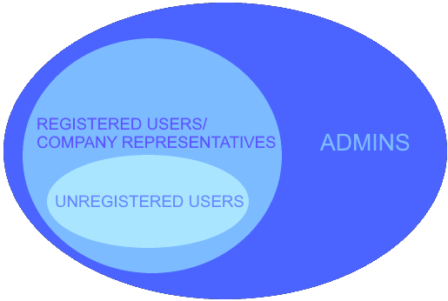

## First user group (unregistered users)

### 2.2.1 Project objectives

Navigate across the interface easily.

View available offers.

Compare product prices.

Ability to see similar products.

### 2.2.2 User characteristics

* Users must be able to use internet browser.
* Users must be interested in gaming.
* Users should have basic knowledge of the specifications of their operating system.

### 2.2.3 User types

Beginner experience users.

### 2.2.4 Computerized tasks

|  |  |  |
| --- | --- | --- |
| **Task** | **Frequency (times a week)** | **Duration** |
| Browse available games | 10 | 0,05 min |
| Search for specific games | 5 | 1 min |
| Compare offered product prices between various sellers. | 10 | 5 min |
| View reviews | 10 | 10 min |
| Compare the user system specifications to the one required of the product | 10 | 3 min |

### 2.2.5 Problems and unexploited opportunities

Searching for games might be too broad.

### 2.2.6 Vision of improved interaction design

Showing a recommended list according to the searches made on that website.

Add advanced search filter to narrow down specific games the users are interest in.

Add comparison between different sellers so users could find the best price for the game they want.

Add comparison to the system of the users so they could see if their computer will run the game.

### 2.2.7 Usability goals for the essential computerized tasks

|  |  |  |  |
| --- | --- | --- | --- |
| **Task** | **Goal** | **Limited use** | **Full use** |
| View list of all games | Effectiveness | - | 2 steps |
| Search for specific games | Learnability | 1 min | 2 min |
| Compare offered product prices between various sellers. | Learnability | 1 min | 2 min |
| View reviews | Efficiency | 0.5 min | 1 min |
| Compare the user system specifications to the one required of the product | Learnability | 1 min | 2 min |

## Second user group (registered users)

### 2.3.1 Project objectives

Should be able to update their wish-list.

Should be able to leave reviews.

Making an account might take too much time.

Should make a purchase easily.

Should be able to get support from the community.

### 2.3.2 User characteristics

* Users must be interested in gaming.
* Has a basic understanding about online shopping.

### 2.3.3 User types

Average experience users.

### 2.3.4Computerized tasks

|  |  |  |
| --- | --- | --- |
| **Task** | **Frequency(per week)** | **Duration** |
| Logging in | 20 | 0.1 min |
| Discuss products and problems with other users | 20 | 5 min |
| Making a wish-list | 5 | 0.3 min |
| Purchase desired product | 3 | 1 min |
| Request a refund | 1 | 5 min |
| Report users | 1 | 3 min |

### 2.3.5 Problems and unexploited opportunities

Creating user account takes time.

Buying a game might be confusing with all the fields you have to fill.

Using credit card online is dangerous.

Buyers should be able to get their money back.

### 2.3.6 Vision of improved interaction design

Possibility to create user account by logging in with Google or Facebook account.

Add possibility to save the buyer information so the users would not need to input it every time they make a purchase.

Add buyer’s protection.

### 2.3.7 Usability goals for the essential computerized tasks

|  |  |  |  |
| --- | --- | --- | --- |
| **Task** | **Goal** | **Limited use** | **Full use** |
| Logging in | Efficiency | 0.5 min | 0.5 min |
| Discuss products and problems with other users | Effectiveness | 1 min | 2 min |
| Making a wish-list | Efficiency | 1 min | 1 min |
| Purchase desired product | Learnability | 1 min | 3 min |
| Request a refund | Efficiency | 0.5 min | 1 min. |
| Report users | Learnability | 0.5 min | 0.5 min |

## Third user group (Company representatives)

### 2.4.1 Project objectives

Offer their products to other users.

Should be able to link their official sites to the product descriptions on other sites.

### 2.4.2 User characteristics

Users should be able to provide intriguing representations of their products.

Should be able to interact with customers in a polite way.

### 2.4.3 User types

Average experience users.

### 2.4.4 Computerized tasks

|  |  |  |
| --- | --- | --- |
| **Task** | **Frequency(per week)** | **Duration** |
| Create product description | - | 10 min |
| Interact with customers | 30 | 15 min |
| See what customers search for the most | 1 | 1 min |
| Change comment section availability of user’s own products | - | 10 min |

### 2.4.5 Problems and unexploited opportunities

Users should be informed about any new reviews or purchases made on their products.

User search statistics might be confusing.

User reviews might be unnecessary.

### 2.4.6 Vision of improved interaction design

Add a new section in user’s notifications for their products.

Categorize user search statistics by game genre.

Allow users to turn off the comment section of their products.

### 2.4.7 Usability goals for the essential computerized tasks

|  |  |  |  |
| --- | --- | --- | --- |
| **Task** | **Goal** | **Limited use** | **Full use** |
| Create product page | Effectiveness | 3 min | 5 min |
| Interact with customers | Efficiency | 1 min | 3 min |
| See what customers search for the most | Learnability | 0.5 min | 0.5 min |
| Change comment section availability of user’s own products | Learnability | 0.5 min | 0.5 min |

## Fourth user group (Administrators)

### 2.5.1 Project objectives

Should be able to see all available functions of the site.

Must be able to detect and solve problems.

Administrators should have effective system of reviewing new products.

Should be able to provide support to users.

### 2.5.2 User characteristics

* Administrators need to have knowledge of computers and networks.
* Need to be ready to resolve conflicts

### 2.5.3 User types

Experienced users.

### 2.5.4 Computerized tasks

|  |  |  |
| --- | --- | --- |
| **Task** | **Frequency(per week)** | **Duration** |
| Review new products | 10 | 30 min |
| Modify users accounts permissions | 30 | 3 min |
| Modify messages and permissions in various communities | 25 | 1 min |
| Provide customer support | 30 | 10 min |

### 2.5.5 Problems and unexploited opportunities

Dangers to the system and servers from hackers.

Buyer information can be compromised.

Possible misinformation about the provided product to the customers.

Products provided by the users can include malicious programs.

Comment section might have users who spam or leave inappropriate messages.

Users might request a refund.

Comments might be filled with repeating questions or problems.

### 2.5.6 Vision of improved interaction design

Improve the defense of the system with trusted third-party software.

Add alternative payment methods that do not require direct credit card info.

Group new products decreasingly by the date they are uploaded in a new section, so admins could review them. Reviewed products go into the market.

Provide user support on getting the money back from the seller.

Introduce the Frequently Asked Questions (FAQ). Link every repeating question to where they were answered and block further commenting on the repeating questions.

### 2.5.7 Usability goals for the essential computerized tasks

|  |  |  |  |
| --- | --- | --- | --- |
| **Task** | **Goal** | **Limited use** | **Full use** |
| Review new products | Learnability | 2 min | 5 min |
| Modify users accounts permissions | Effectiveness | 2 min | 4 min |
| Modify messages and permissions in various communities | Effectiveness | 1 min | 2 min |
| Provide customer support | Effectiveness | 1 min | 5 min |

# INSPIRING INTERACTION IDEAS

## Website: “Digital video game store”

<https://store.steampowered.com/>

You can check the grouping of genres and select the preferred one with only few clicks. It saves time and the website is comfortable and easy to use for the beginners. (See fig. 1)

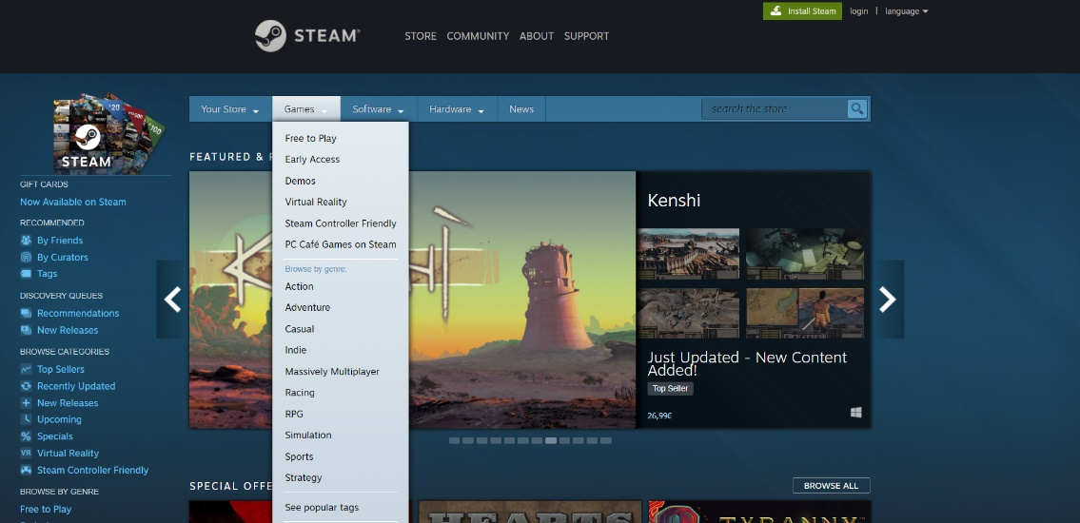

Figure 1 – Steampowered.com

## Website to purchase games

<https://www.origin.com/irl/en-us/store>

This website is convenient for user to refund games that they disliked or couldn’t run. (See fig.2)

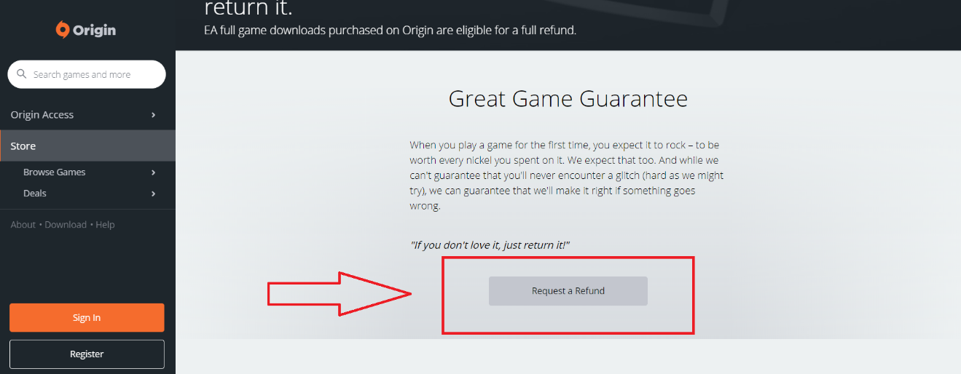

Figure 2- Origin.com

## Website to purchase indie developer games

<https://itch.io/>

This website is good for indie developers, because it is easy to publish their games. Administrators will check the game before it gets published to the store.

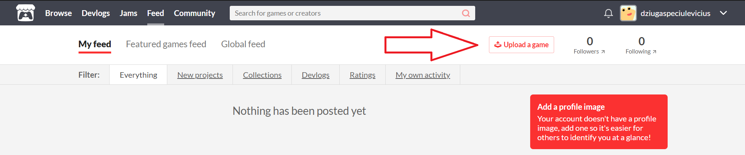

Figure 3.1 - Itch.io

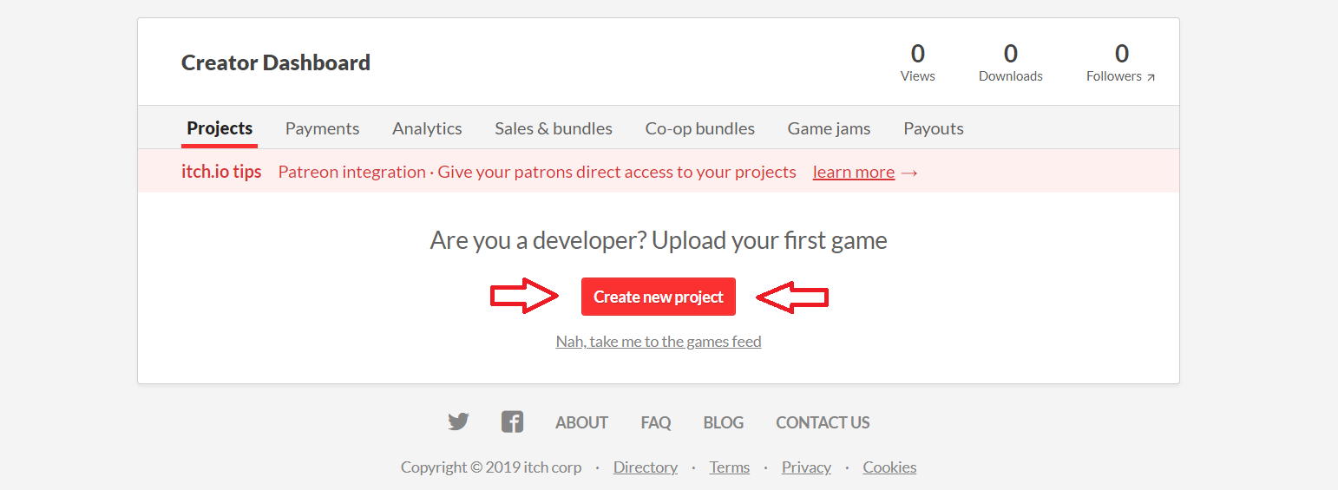

Figure 3.2 - Creating a new project

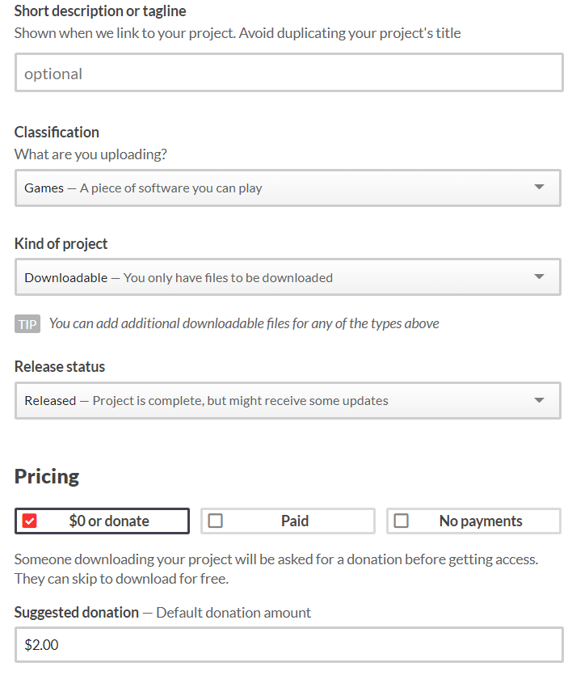

Figure 3.3 - Setting up a project

## Website for great game deals

<https://www.humblebundle.com/>

This website often has bundle sales which often sells a lot of games bundled together with a great price. This often attracts people and they’re most likely to buy it.

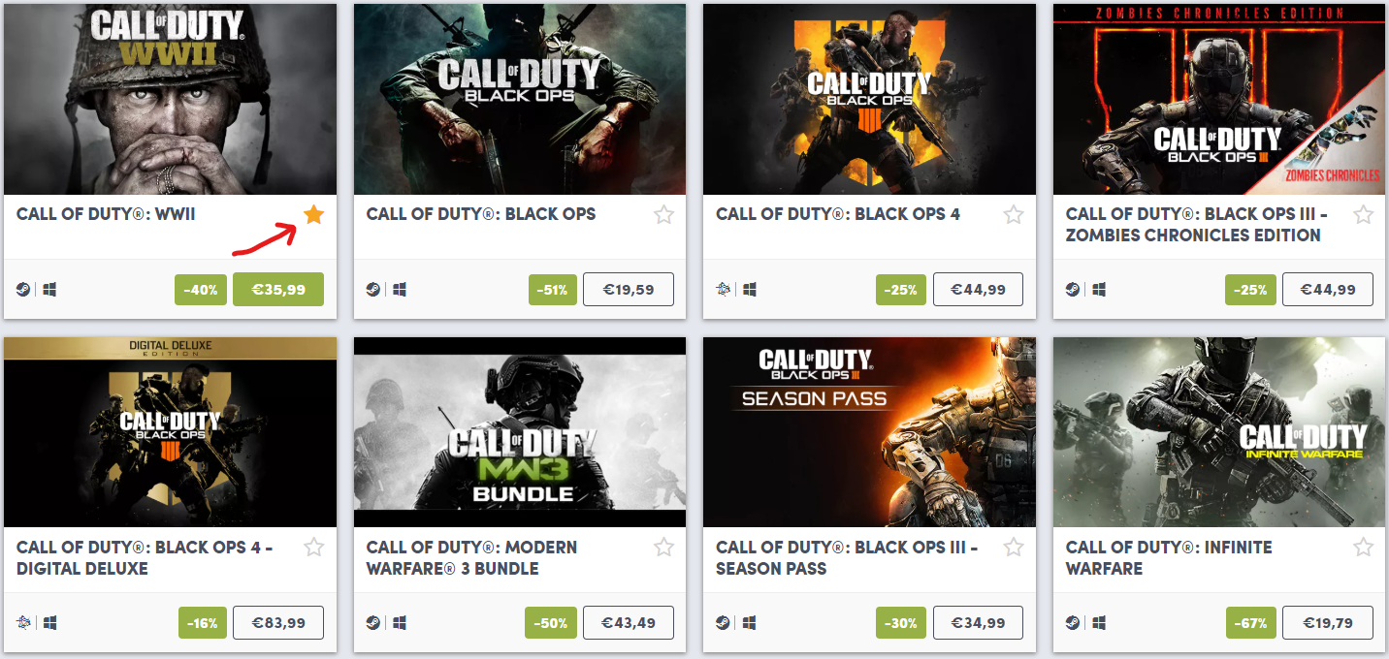

Figure 4.1 -humblebundle.com

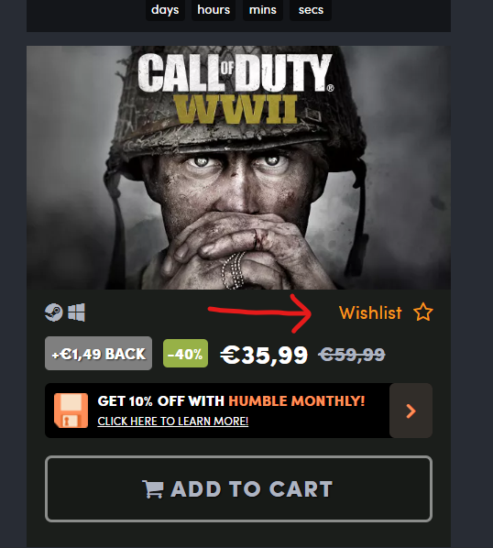

Figure 4.2 – Adding a game to our Wish List

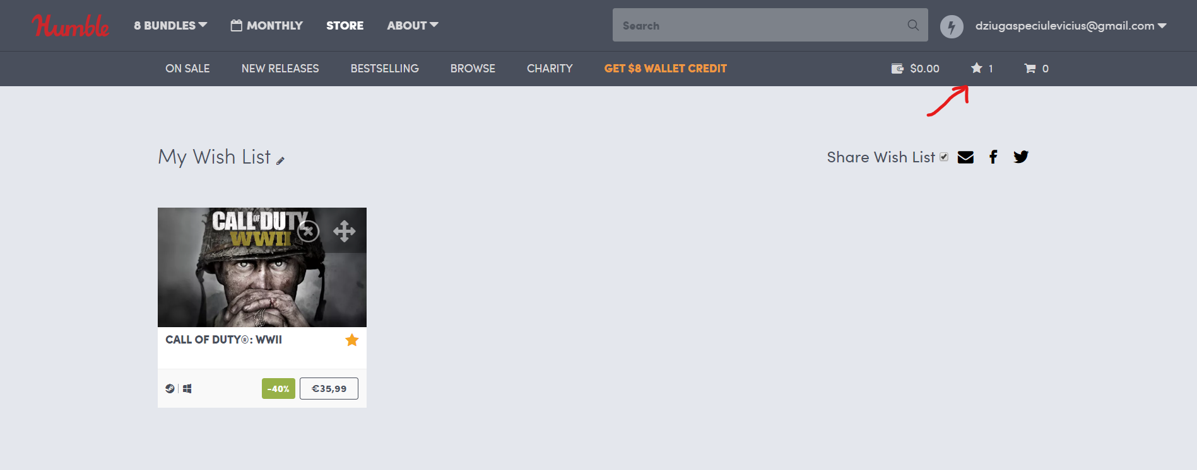

Figure 4.3 – Wish List page

## DRM-free (Digital Rights Management) website

<https://www.gog.com/>

This website has DRM-free games which can be played offline. A DRM-free game is just that—a game whose developer trusts you as a buyer not to copy and release the product.

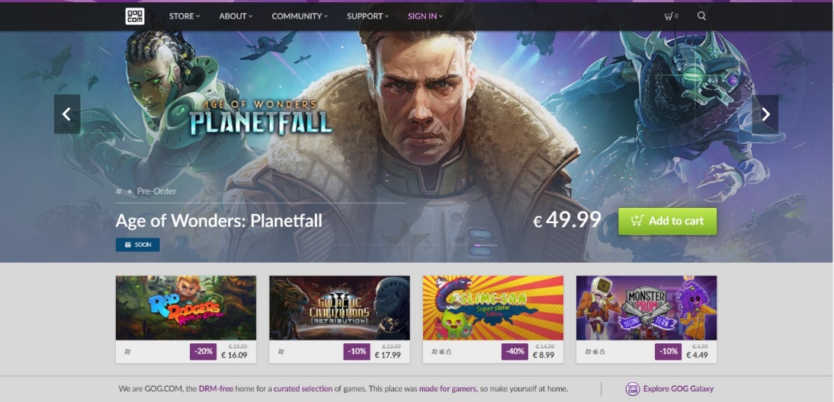

Figure 5 - gog.com

# CONCLUSION

By designing our future system, we have learned to analyze our potential users and define their needs in system that they will use. We learned how to plan functions, create goals for our functions and analyze their usage in our future system, analyze potential problems in our system and how we could fix it. As well as visualize it with the help of our inspirations about potential system.